**CENWP-OD-B25 July 2023**

**MEMORANDUM FOR THE RECORD**

**SUBJECT: 23BON067 MFR Bradford Island Picket Leads Salmonid Mortality**

On the morning of 25 July, Project Biologists discovered one juvenile Salmonid mortality on the Bradford Island picket leads. It appears the fish jumped onto the picket leads as there were no signs of avian predation. The fish was scanned for PIT tags, inspected, and returned to the river.

1. Species – Chinook (*Oncorhynchus tshawytscha)*
2. Origin – Unknown
3. Length – 22.9 cm
4. Marks and tags – Adipose clip
5. Marks and Injuries found on carcass – None
6. Cause and Time of Death – Unknown
7. Future and Preventative Measures – Possibly install netting

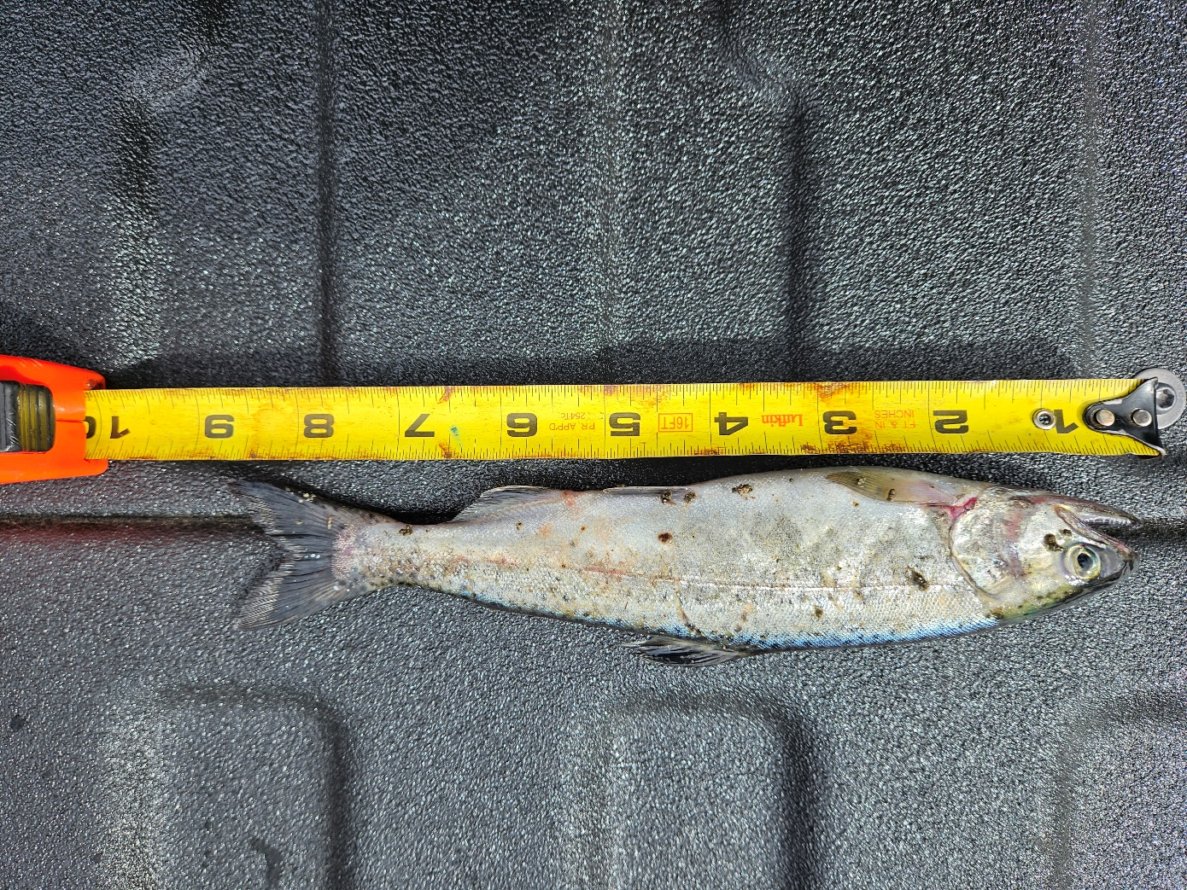

Sincerely,

BON Project Fisheries